Build your own mono-pod !

I hunt the deserts of California and here it is against the law to hunt from a vehicle. Because of the often very flat land and the tall brush it is often necessary to stand and shoot in order to see over the top of all that brush. A mono-pod or bi-pod greatly increases your accuracy to insure a good shot. Under the conditions that I am using the support, I prefer to use the mono-pod. It allows me to quickly move and place the pod and I don’t have to worry about placing the individual legs of a bi-pod.

Many sporting goods stores and websites have mono and bi-pods available, but I was shocked at the prices. Cabela’s carries a mono-pod from Stoney Creek for $35 plus shipping charges and any applicable taxes. After seeing another homemade mono-pod I made a trip to Wal-Mart and picked up the parts I will need to make my own extendable mono-pod for under $15!

In the paint section I got a can of cheap flat black spray paint for $0.94 that I will use to paint the home made mono-pod once I have it completed. (I chose to use black instead of camouflage because I will be using it at night.) There in the paint section I also found and expandable handle designed to be used as a handle on a paint roller. To expand it you simply twist the two pieces until you are able to slide the top section within the lower section. Once you get it to the height where you want it simply twist the two sections in the opposite directions and lock them together. I picked this one up for just $8; it is a 3’ to 6’ extension.

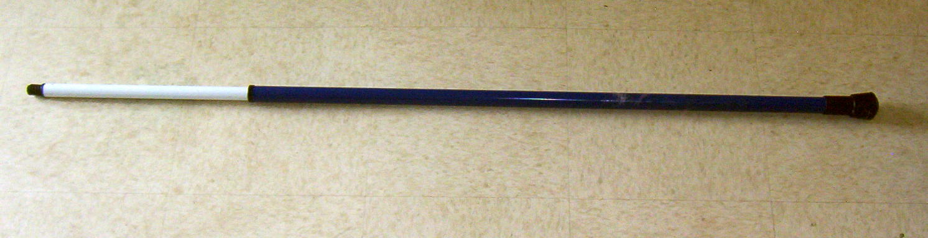

Right next to the paint section was the hardware. I picked up a rubber foot intended to be used on a chair leg that was about $2 for two. I will glue this to the handle end of the paint roller extension handle and will place it on the ground when I am using the mono-pod. Also in this section I picked up a screw in style prong that I will rest the gun in. It has two prongs and is shaped like a “ U” with the screw at the bottom of the curve pointed away from the “U” making a funny looking “Y”. (If the fore end of your rifle is wide you may need to go to a different store and get one that is a little wider.) The one I got at Wal-Mart was about $0.75, if you get a bigger one it will be more expensive. Another option is to use a pair of pliers and a little muscle and bend a smaller one to fit your needs. I ended up with a smaller one and am going to bend mine to fit and keep my cost down.

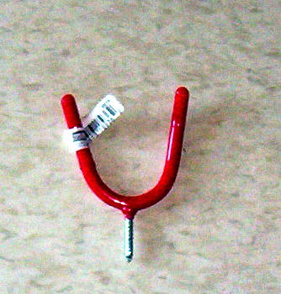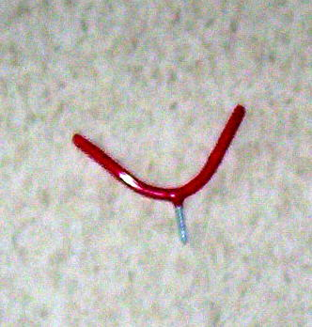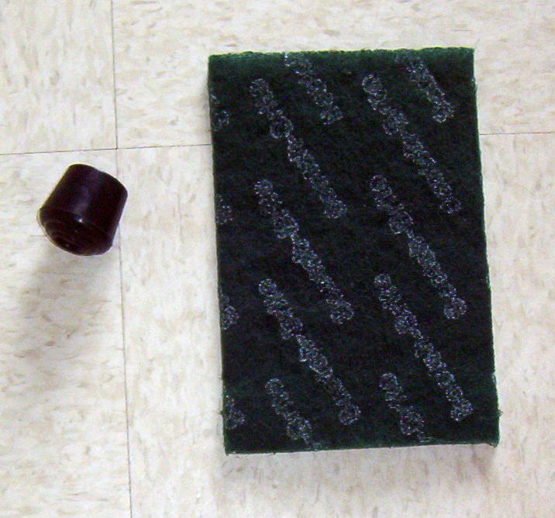

If you go to any hardware or home improvement stores such as True Value, Lowe’s,
or Home Depot you should be able to find one of the extendable paint rods that are a little fancier (and more expensive) than the one I picked up at Wal-Mart. The cheaper model I bought works fine, I am using it simply to keep the cost down of my project.

I didn’t pick any up while I was at Wal-Mart because I have some at home but you might want to pick up some scotch-brite to rough the surfaces of your mono-pod so that the paint will adhere and stay. If you have a manufactures sticker on the extension rod that leaves a nasty sticky residue when you peel off the sticker try a little WD-40; it should take it right off. If you do use the WD-40 you may want to use some kind of detergent to get off the oily residue so that paint will stick.

Because the coating is bright red on the screw in prong I am going to try putting black tape on it since my rifle stock is going to be making contact with it; I don’t want to have to keep removing paint from stock. You might also be able to use shrink tubing to or even find some foam that will work. If you find something that work well let me know and I will add it to this page.

